

SIMATS ENGINEERING

Saveetha Institute of Medical and Technical Sciences
Chennai- 602105

Student Name: Mugesh S Reg. No.:192411055
Course: ITA0312 - Mobile Computing Course Faculty: Dr. Sudha I
LAB EXPERIMENT – 4
EXP 4: Create a visual representation in Figma highlighting the key elements of mobile network protocol stacks.
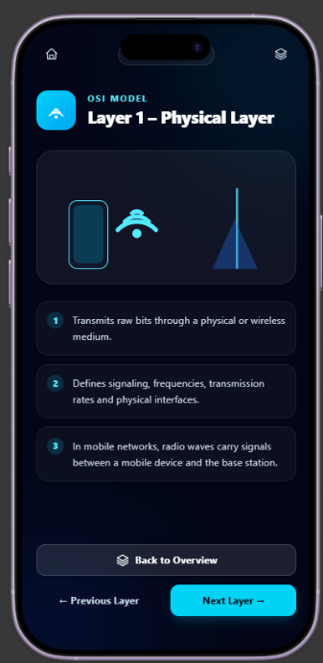
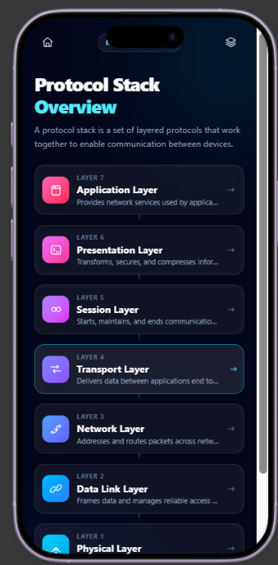
Output Screenshots:
